**Project Report**

Print Name and Introduction

## Submitted by

Muhammad Ali

## Supervised by

Sir Mehmood Ali

Copyright © 2024 Solo Choicez. All rights reserved.

No part of this publication, in whole or in part, may be reproduced, copied, transferred or any other right reserved to its copyright owner, including photocopying and all other copying, any transfer or transmission using any network or other means of communication, any broadcast for distant learning, in any form or by any means such as any information storage, transmission or retrieval system, without prior written permission from Solo Choicez.

Table of Contents

**1.0 Introduction 1**

**2.1 Project Introfuction 1**

**2.2Objective 1**

**3.0 Project Summary 2**

**4.1 Development Structure 3**

**4.2 Output ………………………………………………………………………………………………………………………………………3**

**4.3 Conclusion ……………………………………………………………………………………………………………………………..…3**

**4.4 Recommendation……………………………………………………………………………………………………………………..4**

## Introduction :

Muhammad Ali is a recent graduate from Alhamd Islamic University, where he earned a degree in Computer Science. With a strong foundation in the latest technological advancements and programming techniques, Muhammad is well-prepared to enter the professional world of technology.

During his academic tenure, Muhammad gained hands-on experience through various projects and coursework that honed his skills in software development, data analysis, and systems design. His education at Alhamd Islamic University has equipped him with both the theoretical knowledge and practical expertise needed to contribute effectively to the field of computer science

## 2.1Project Introduction :

## The Python program "Name and Introduction" is a simple yet effective application designed to introduce users to the basics of programming. This program focuses on taking input from the user, such as their name, and then generating a personalized introduction message. It is an ideal starting point for beginners to understand fundamental programming concepts like input handling, string manipulation, and output display.

## The primary objective of this program is to familiarize users with the structure and syntax of Python, while also demonstrating how a program can interact with the user in a meaningful way. By engaging with this program, users will gain insight into how to create interactive scripts that can be customized according to user input, setting the foundation for more complex programming tasks in the future.

## 2.2 Objective

## The objective of the "Name and Introduction" Python program is to provide a hands on learning experience for beginners in programming. This program aims to:

## Introduce Basic Programming Concepts: Demonstrate fundamental programming concepts such as user input, string manipulation, and output generation in a simple and approachable manner.

## Enhance User Interaction Skills: Teach users how to create interactive programs that respond to user input, reinforcing the concept of dynamic programming.

## Build a Foundation for Further Learning: Serve as a stepping stone for learners to advance to more complex programming tasks by solidifying their understanding of basic Python syntax and structure.

## Encourage Customization and Creativity: Inspire users to modify and expand the program, allowing them to explore their creativity and problem-solving skills within the Python programming environment.

## Requirements

## HARDWARE

|  |  |
| --- | --- |
| **Tools** | **Description** |
| Computer/ laptop | RAM min 4GB, Prcocessor minimum I 3, Hard drive for saving purpose minimun 128 GB |

**SOFTWARE**

|  |  |
| --- | --- |
| **Tools** | **Description** |
| Window/Mac/Linux | Graphical operating system and development |
| Python3.14 | A high-level programing language. |
| Visual studio code | Visual Studio Code is a streamlined code editor with support for development operations like debugging, task running, and version control. |
| Libraries | A collection of prewritten code that you can use to perform specific task. |

# 3.0 Project Summary The "Name and Introduction" Python program is designed as an introductory project for individuals new to programming. The program prompts the user to enter their name and then generates a personalized introduction message. This simple interaction demonstrates key programming principles such as receiving user input, processing data, and outputting a customized result.

# This project serves as an essential learning tool, offering beginners a practical way to grasp the basics of Python programming. By working through the code, users gain an understanding of core programming concepts, which are crucial for building more complex applications in the future.

# The project’s straightforward nature allows for easy customization, encouraging users to experiment with the code and explore additional features, such as adding more input prompts or customizing the output format. Through this hands-on approach, the "Name and Introduction" program not only teaches fundamental skills but also fosters a deeper interest in programming, laying a solid foundation for future development in the field.

## 4.1 Development Algorithm and Code :

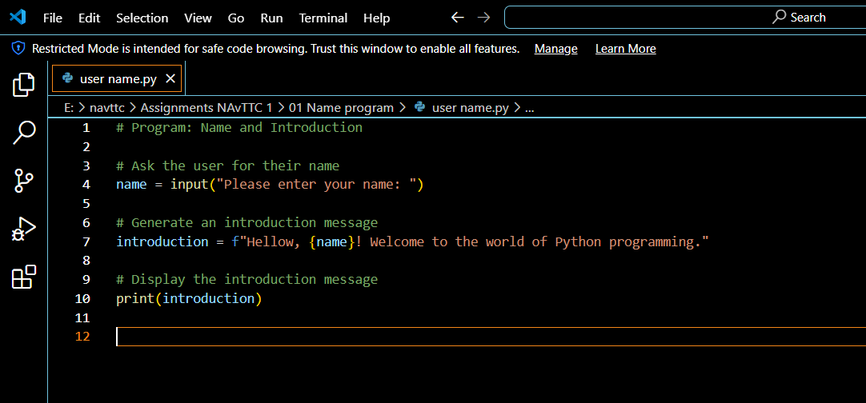

## 4.2 Output :

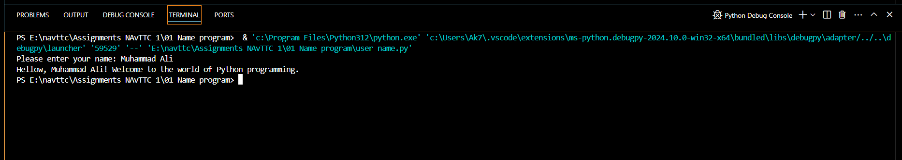

## 4.3 Conclusion:

In conclusion, the print name and introduction program demonstrates the fundamental principles of software development through its simple yet effective functionality. By allowing users to input their name and receive a personalized introduction, the program not only showcases basic input/output operations but also emphasizes the importance of user interaction in software design.

This program serves as an excellent starting point for understanding how to handle user input, process data, and display output in a meaningful way. It illustrates key programming concepts such as variable assignment, string manipulation, and user interface design, providing a solid foundation for more complex projects.

Overall, the print name and introduction program is a valuable educational tool for new programmers, offering practical experience in crafting user-friendly applications and reinforcing core programming skills.

## 4.4 Recommendations:

* To improve the print name and introduction program, consider the following basic recommendations:
* Error Handling: Add basic error handling to manage any potential issues with user input, ensuring the program runs smoothly.
* User Experience: Enhance the user experience by adding clear instructions or prompts to guide users on how to enter their name.
* Code Comments: Include comments in the code to explain its functionality, making it easier for others to understand and modify.
* Testing: Test the program with different inputs to ensure it handles various cases correctly and consistently.

These simple improvements can help make the program more reliable and user-friendly.